Column 1 (Officer name and details)
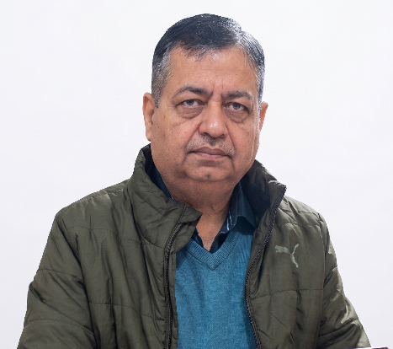
Dr. Samir Khajuria
BMO Chowki Choura
(Staff Button)
Staff excel

Column 2 (Photo Gallery)
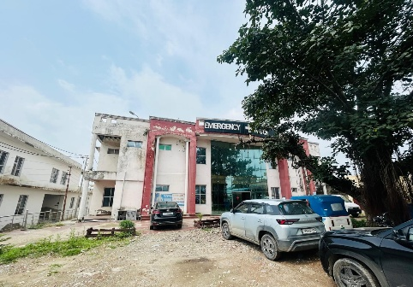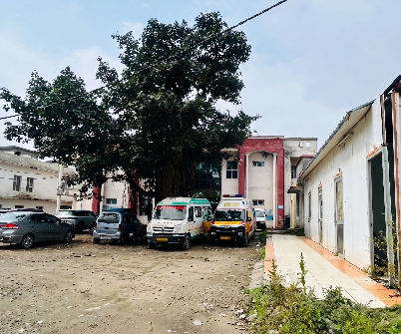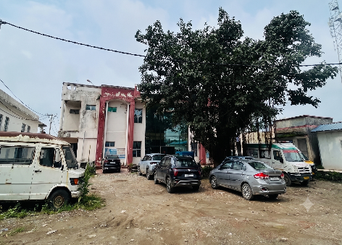

Column 3 (Google location)
Map Location
https://maps.app.goo.gl/cfTV1zVdSd2UCqis9?g_st=iwb

Column 4 (PHC’s)
PHC’s Excel

Column 5 (Infrastructure)
Infrastructure Excel

Column 6 (Equipment used)
Equipment Excel

Column 7 (Next Year Roadmap)
Not available yet

Background picture

